# Lab 3: CSS

# Prepare your project:

* Download the provided starter code.
* Add a css/css-reset.css stylesheet to your project(create an empty CSS file, then use the extension ctrl+alt+r, on MacOS: cmd+alt+r to generate a set of CSS rules that reset the defaults of the browser).
* Add the reference to this file from all your future HTML files. These CSS rules will cancel all browser default styles.
* To have a clean html file, create your CSS rules in the external file css/styles.css, notice the link tag in the head section:

<link rel=”stylesheet” href=”css/styles.css”>

# General CSS rules:

1- Add a font-size property for each of your elements. For example, 16px for all text in your page, then 14px for all paragraphs, 12px for any text inside the footer (think of using property inheritance).

2- Change the color of the header font appropriately.

3- Add a background for paragraphs, example: background: *#eef*;

4- Add a text-transform property to your header to make it uppercase (search on the web).

5- Add a margin for articles and sections to 20px auto. Add margins for texts of 5px auto.

6- Add padding to your images, nav, texts and aside elements.

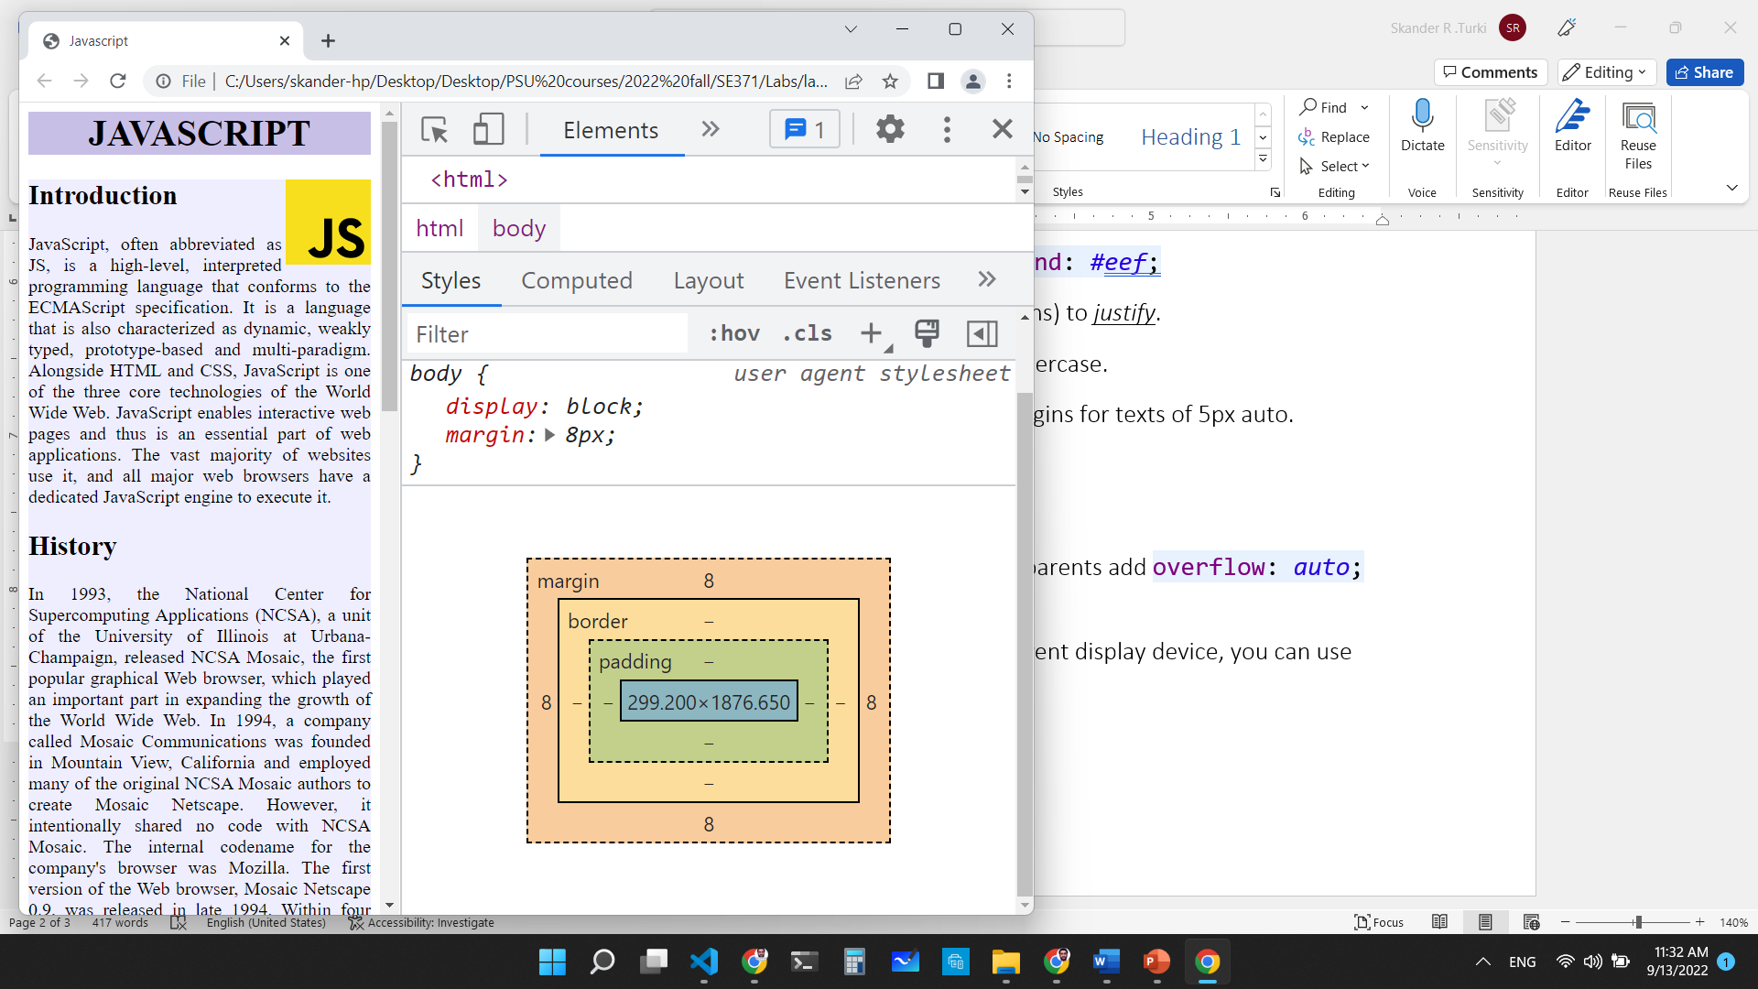

# Style the table:

Open the provided code (home.html). Then, apply the following style to your table:

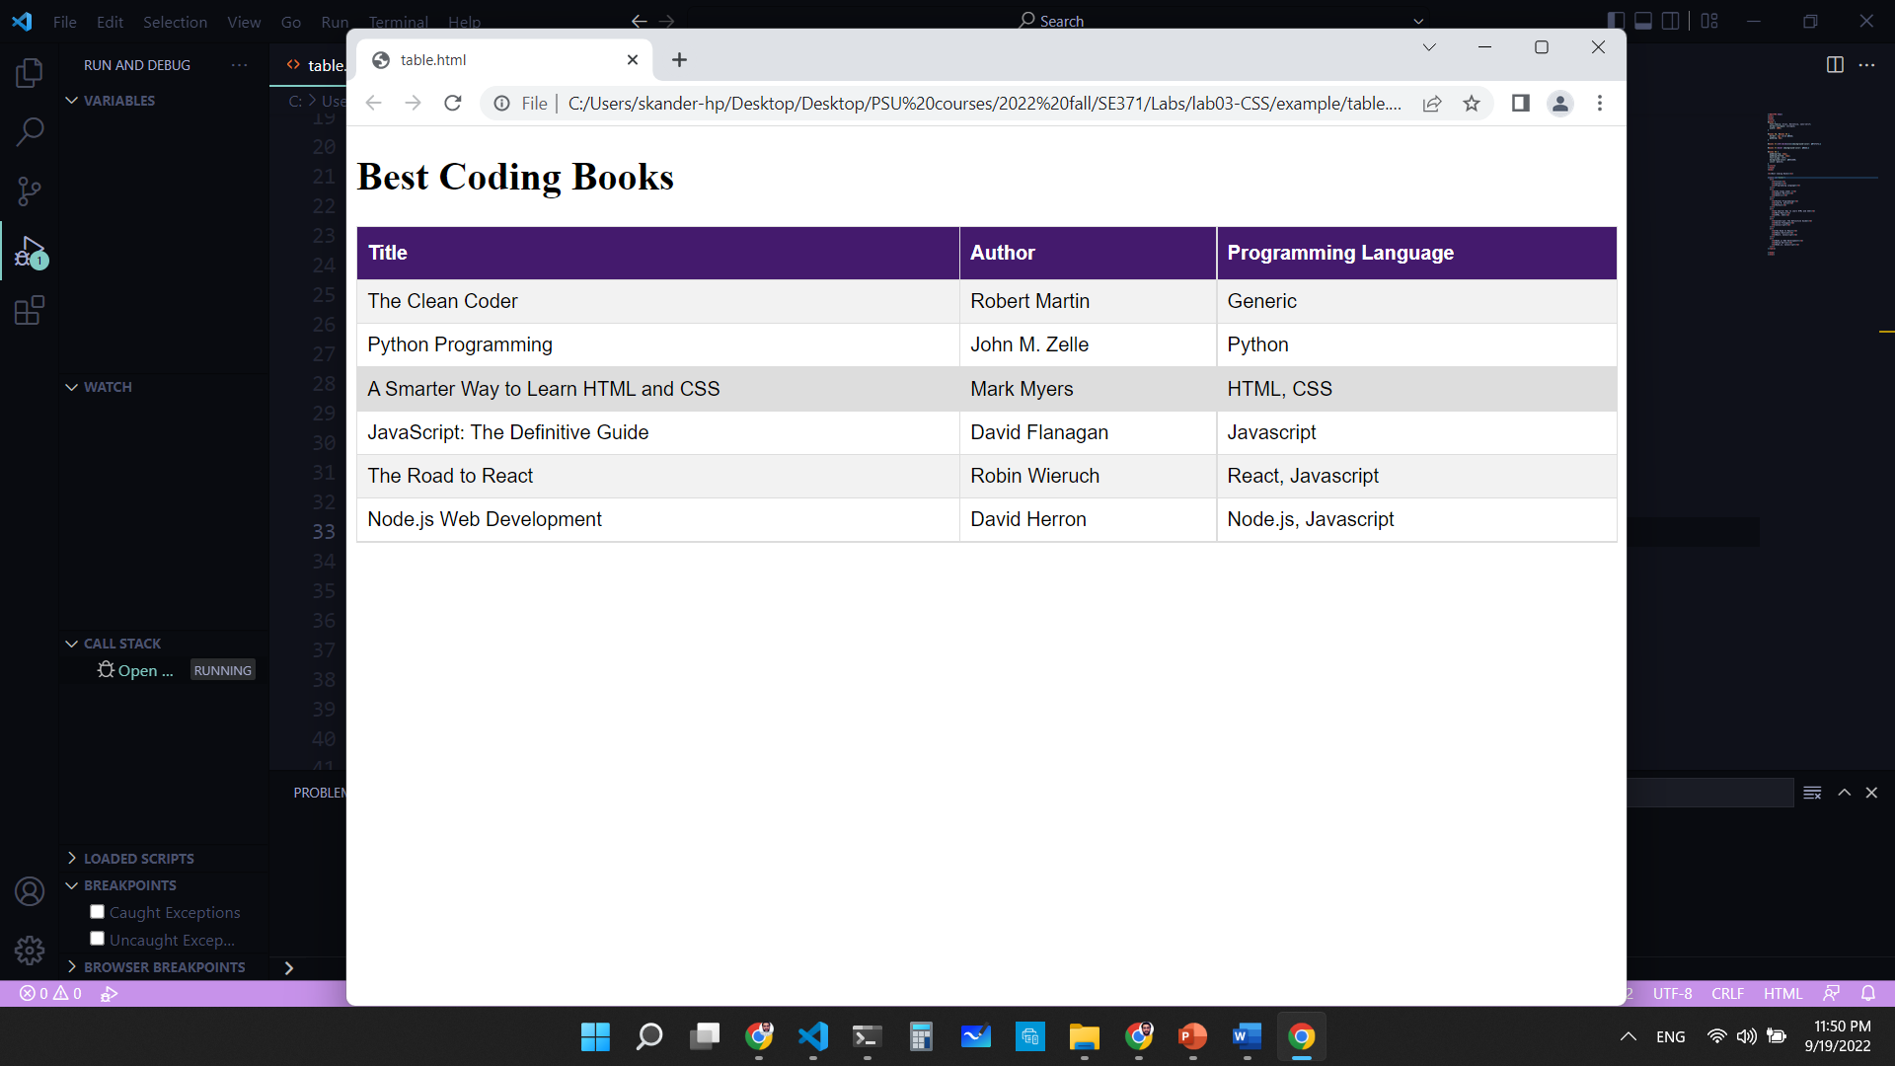

Fig 1. Style to apply to your table.

Steps:

1. For the table, use an ID selector and create these rules:
   1. The borders should be collapsed (border-collapse property).
   2. Width: must be 100 % of the parent.
2. For the td and th elements:
   1. Add a solid border of 1 pixel with a color of your choice.
   2. Add a padding of 8 pixels.
3. For the th:
   1. Add top and bottom paddings of 12 pixels.
   2. Align text to the left.
   3. Add a background color of your choice.
   4. Change the font color to create a strong contrast with the background.
4. Finally, for the tr:
   1. Add a css rule to highlight the row below by the mouse position.
   2. Change the background color of even rows for better visibility.

END